

Day16 assignment

BHANU PRAKASH REDDDY



February 14, 2022

NB HEALTHTECH

|  |
| --- |
| 1. WACP to print Hello World.  Hint: Think object oriented. |

Code:

//Author: Bhanu Prakash Reddy

//WACP to print hello using object oriented program

class Message

{

public static void PrintHello()

{

Console.WriteLine(@"

_ _ __ __ _ _ _

/\ /\___| | | ___ / / /\ \ \___ _ __| | __| | / \

/ /_/ / _ \ | |/ _ \ \ \/ \/ / _ \| '__| |/ _` |/ /

/ __ / __/ | | (_) | \ /\ / (_) | | | | (_| /\_/

\/ /_/ \___|_|_|\___( ) \/ \/ \___/|_| |_|\__,_\/

|/ ");

}

}

internal class Program

{

static void Main(string[] args)

{

Message.PrintHello();

Console.ReadLine();

}

}

Output:

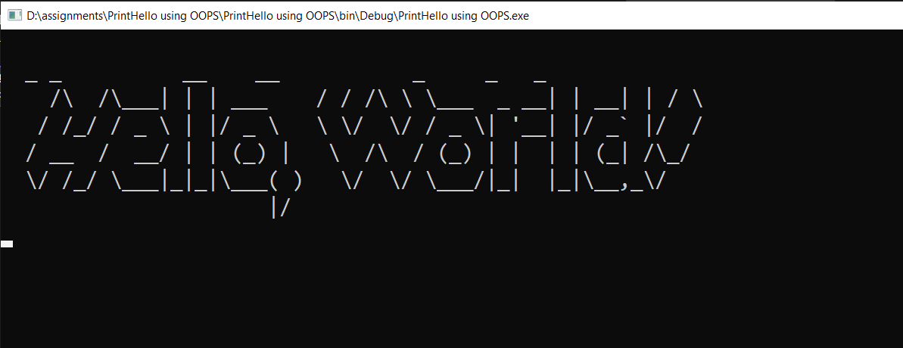

|  |
| --- |
| 2. WACP to read a number from user and print factorial of it.  Hink: Think object oriented. |

Code:

// Author:Bhanu Praksh Reddy

//WACP for factorial using OOPs

class Factorial

{

int input;

/// <summary>

/// Read data from user

/// </summary>

public void ReadData()

{

Console.WriteLine("Enter any Number: ");

input= Convert.ToInt32(Console.ReadLine());

}

/// <summary>

/// Calculating factorial

/// </summary>

/// <returns>Factorial of a number</returns>

public int GetFactorial()

{

int fact = 1;

for(int i=1;i<=input;i++)

{

fact *= i;

}

return fact;

}

}

internal class Program

{

static void Main(string[] args)

{

Factorial f = new Factorial();

f.ReadData();

Console.WriteLine($"Factorial of the number is {f.GetFactorial()}");

Console.ReadLine();

}

}

Output:

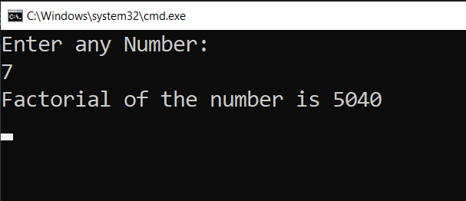

|  |
| --- |
| 3. For the console application created in 2nd task, add screen shot of the .exe file location. |

Screenshot:

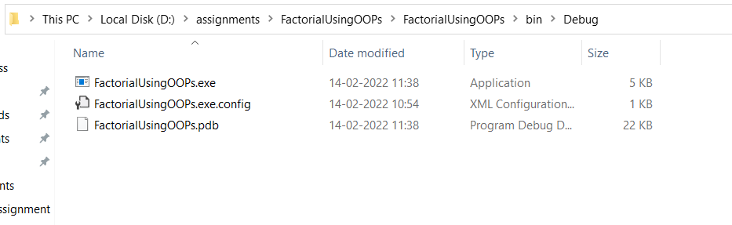

|  |
| --- |
| 4. Create a Class Library Project with name as  <YourName>Library (Example: MeganadhLibrary)  Create a class Mathematics as discussed in the class.  [ Add methods for reading number and finding factorial]  Re-Build the project and you will get a .dll file.  (Put the screen shot of this)  Copy the dll file to your desktop  (put the screen shot of this) |

Code:

namespace BhanuLibrary

{

//Author:Bhanu Prakash Reddy

//Create class library with name

public class Mathematics

{

int input;

/// <summary>

/// Read data from user

/// </summary>

public void ReadData()

{

Console.WriteLine("Enter any Number: ");

input = Convert.ToInt32(Console.ReadLine());

}

/// <summary>

/// Calculating factorial

/// </summary>

/// <returns>Factorial of a number</returns>

public int GetFactorial()

{

int fact = 1;

for (int i = 1; i <= input; i++)

{

fact *= i;

}

return fact;

}

}

}

Output:

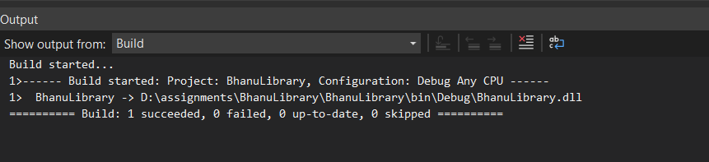

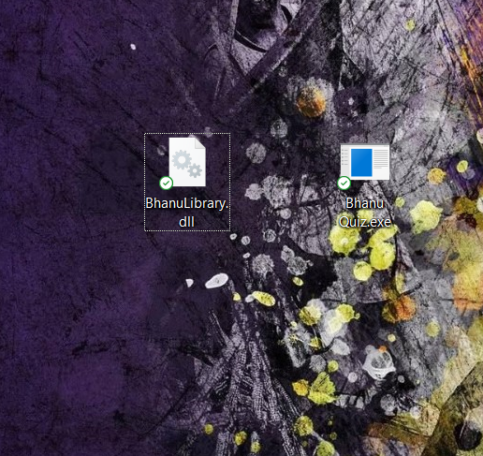

|  |
| --- |
| 5. Create a class library with three classes in it:  a. Mathematics  b. Physics  c. Chemistry  and add methods as discussed in the class  refer all the three classes in a console application. |

Code:

namespace ClientApp

{

internal class Program

{

static void Main(string[] args)

{

Mathematics m = new Mathematics();

Console.WriteLine(m.Add(4,5));

Console.WriteLine(m.Sub(9, 5));

int u = 6;

int a = 4;

int t = 3;

Physics p = new Physics();

var v = p.Finalvelocity(u,a,t);

Console.WriteLine($"Final velocity is {v}");

Chemistry c = new Chemistry();

Console.WriteLine(c.GetWater());

Console.ReadLine();

}

}

}

namespace BhanuLibrary_with_three_classes

{

public class Chemistry

{

public string GetBenzene()

{

return "C6H6";

}

public string GetWater()

{

return "H2O";

}

public string GetEthane()

{

return "CH4";

}

}

}

namespace BhanuLibrary_with_three_classes

{

public class Physics

{

public int Finalvelocity(int u, int a, int t)

{

return u + a * t;

}

}

}

namespace BhanuLibrary_with_three_classes

{

public class Mathematics

{

public int Add(int a,int b)

{

return a+ b;

}

public int Sub(int a,int b)

{

return a-b;

}

}

}

Output:

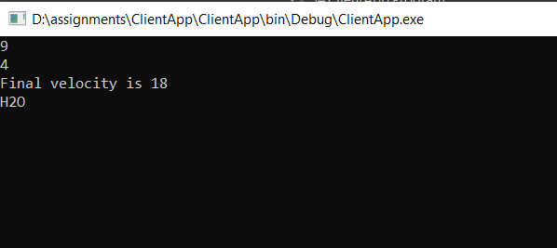

|  |
| --- |
| 6. WACP to print multiplication table of a number. |

Code:

namespace MultiplicationTable_OOPs

{

//Author:Bhanu Prakash Reddy

//WACP for Multiplcation Table using OOPs

class Table

{

int a;

/// <summary>

/// ReadData

/// </summary>

public void ReadTable()

{

Console.WriteLine("Enter Number: ");

a=Convert.ToInt32(Console.ReadLine());

}

/// <summary>

/// Printdata

/// </summary>

public void PrintTable()

{

for(int i = 1; i<=10;i++)

Console.WriteLine($"{a}*{i}={a*i}");

}

}

internal class Program

{

static void Main(string[] args)

{

Table t= new Table();

t.ReadTable();

t.PrintTable();

Console.ReadLine();

}

}

}

Output:

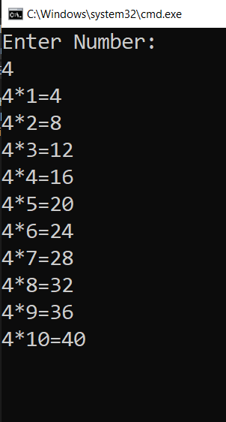

|  |
| --- |
| 7. WACP to check if the given is number is Palindrome or not. |

Code:

namespace PalindromeOrNot_using_OOPs

{

//Author:Bhanu Prakash Reddy

//Wacp For plindrome or not using opps

internal class Program

{

class Palindrome

{

int temp, num, rem, sum = 0;

/// <summary>

/// User input

/// </summary>

public void ReadNumber()

{

Console.WriteLine("Enter Number");

num=Convert.ToInt32(Console.ReadLine());

}

/// <summary>

/// Print Palindrome or not

/// </summary>

public void PrintPalindrome()

{

temp = num;

while(num>0)

{

rem = num % 10;

sum = (sum * 10) + rem;

num = num / 10;

}

if(temp == sum)

Console.WriteLine($"{temp} is Palindrome");

else

Console.WriteLine($"{temp} is not Palindrome");

}

}

static void Main(string[] args)

{

Palindrome p=new Palindrome();

p.ReadNumber();

p.PrintPalindrome();

Console.ReadLine();

}

}

}

Output:

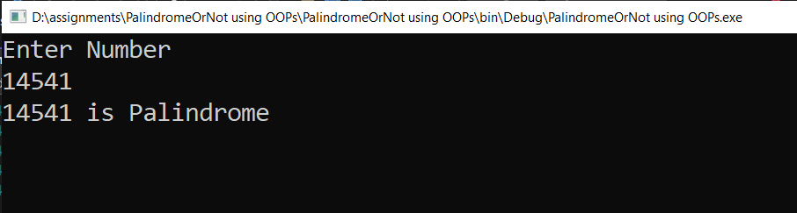

|  |
| --- |
| 8. Create a solution "MyProject" (as discussed in class)  Add three projects  a. YourNameLibrary (and add any class with methods)  b. PublicLibrary (add any class with methods)  c. ClientApp (and here refer above two libraries)  Note: If you are confused., see the video |

Code:

namespace ClientApp

{

//Author:Bhanu Prakash Reddy

//Wacp using two libraries in MyProject

internal class Program

{

static void Main(string[] args)

{

Mathematics m = new Mathematics();

Physics p = new Physics();

m.ReadData();

Console.WriteLine($"Factorial of a number is {m.GetFactorial()}");

Console.WriteLine(Physics.FinalVelocity(4,5,5));

Console.ReadLine();

}

}

}

namespace PublicLibrary

{

public class Physics

{

public static int FinalVelocity(int u, int a, int t)

{

return u + a * t;

}

}

}

namespace BhanuSLibrary

{

public class Mathematics

{

int input;

/// <summary>

/// Read data from user

/// </summary>

public void ReadData()

{

Console.WriteLine("Enter any Number: ");

input = Convert.ToInt32(Console.ReadLine());

}

/// <summary>

/// Calculating factorial

/// </summary>

/// <returns>Factorial of a number</returns>

public int GetFactorial()

{

int fact = 1;

for (int i = 1; i <= input; i++)

{

fact *= i;

}

return fact;

}

}

}

Output:

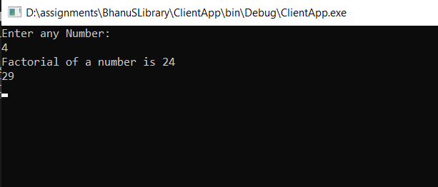

|  |
| --- |
| 9. Add one more project (windows application)  Add some 3 or 4 screen shots just to prove that  you have done this. |

Code:

private void button1_Click(object sender, EventArgs e)

{

Mathematics m = new Mathematics();

int input =Convert.ToInt32(textBox1.Text);

m.input = input;

int fact = m.GetFactorial();

textBox2.Text = fact.ToString();

}

OutPut:

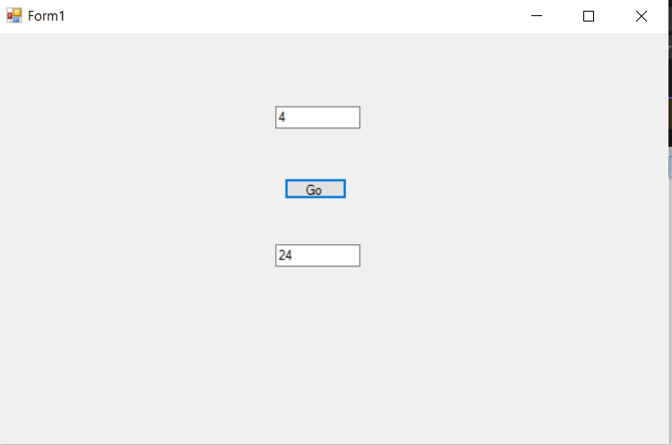

|  |
| --- |
| 10. Research and write what is the use of partial classes  in C#  WRITE EXAMPLE CODE AND PUT SCREEN SHOTS |

Code:

internal class Program

{

static void Main(string[] args)

{

Mathematics m = new Mathematics();

Mathematics2 m2 = new Mathematics2();

Physics p = new Physics();

m.ReadData();

Console.WriteLine($"Factorial of a number is {m.GetFactorial()}");

Console.WriteLine(m2.Add(2, 4));

Console.WriteLine(Physics.FinalVelocity(4,5,5));

Console.ReadLine();

}

}

public partial class Mathematics

{

public int input;

/// <summary>

/// Read data from user

/// </summary>

public void ReadData()

{

Console.WriteLine("Enter any Number: ");

input = Convert.ToInt32(Console.ReadLine());

}

/// <summary>

/// Calculating factorial

/// </summary>

/// <returns>Factorial of a number</returns>

public int GetFactorial()

{

int fact = 1;

for (int i = 1; i <= input; i++)

{

fact *= i;

}

return fact;

}

}

public partial class Mathematics2

{

public int Add(int a, int b)

{

return a + b;

}

public int Sub(int a, int b)

{

return a - b;

}

}

Output:

